The 2nd International Conference on Industrial IoT, Big Data and Supply Chain (IIoTBDSC 20201)
Invitation Letter
September 24-26, 2021, Macao, SAR of China
Dear Author
The 2nd International Conference on Industrial IoT, Big Data and Supply Chain（IIoTBDSC 2021） will be held during September 24-26, 2021 in Macao, SAR of China. In view of your outstanding contributions in this field, we sincerely invite you to attend our conference.
The IIoTBDSC 2021 aims to provide a forum that brings together researchers and academia as well as practitioners from industry to meet and exchange their ideas and recent research development work on all aspects of Industrial Internet of Things, Big Data and Supply Chain, their applications and other related areas. The focus of the conference is to establish an effective platform for institutions and industries to share ideas and to present the works of scientists, engineers, educators and students from all over the world. The organizing committee of conference is pleased to invite prospective authors to submit their original manuscripts to IIoTBDSC 2021.
All papers will be published in “Smart Innovation, Systems and Technologies”（ISSN: 2190-3018）by Springer-Verlag.
The key to success of our conference is to get your support. We will appreciate if you can attend our conference.
Communication Method: Oral Presentation or Poster Exhibition
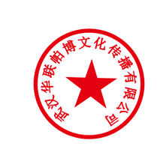
Organizer: Universidade de Macau, Teesside University, Chongqing University of Posts and Telecommunications, University of Electronic Science and Technology of China, Guangdong University of Foreign Studies, University of Chinese Academy of Sciences, Macau University of Science and Technology, Wuhan University, Hunan University of Finance and Economics, Qufu Normal University, University of Constantine 2 and IRNet International Academic Communication Center

IIoTBDSC2021 Conference Committee authorizes Wuhan Hualianpobo Culture Communication Co., Ltd. to draw up invoice and deal with payment.
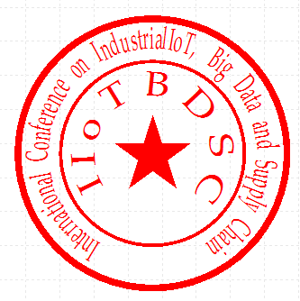
The invoice charge of IIoTBDSC2021 Conference Committee includes publication fee, conference materials. Author themselves should pay accommodation, meals and transportation fee.

IIoTBDSC2021 Conference Committee

第二届工业物联网、大数据与供应链国际会议(IIoTBDSC2021)
邀请函
2021年9月24-26日，澳门，中国

尊敬的 作者
第二届工业物联网、大数据与供应链国际会议(IIoTBDSC2021)将于2021年9月24-26日在中国澳门举办。鉴于您工业物联网、大数据与供应链及相关领域的突出贡献，IIoTBDSC会务组真挚的邀请您参加并出席本次大会，您的热情支持是大会取得圆满成功的重要前提，特此感谢您的莅临。
本次大会接受的所有文章将在Springer旗下论文集刊“Smart Innovation, Systems and Technologies”（ISSN: 2190-3018）上进行发表。
一、会议主题：
The 2nd International Conference on Industrial IoT, Big Data and Supply Chain (IIoTBDSC2021)
二、会议地点：
St. Regis Macao （澳门瑞吉酒店）
三、交流方式：
口头报告&海报展示
四、主办方
英国提赛德大学、中国科学院大学、重庆邮电大学、湖南财政经济学院、澳门大学、澳门科技大学、曲阜师范大学、广东外语外贸大学、电子科技大学、武汉大学、阿尔及利亚康斯坦丁第二大学和IRNet 国际学术交流中心
IIoTBDSC 2021会务组委托武汉华联帕博文化传播有限公司代为收款并开具发票以及安排相应的会务活动。参会期间的差旅和食宿由参会作者自行承担。

IIoTBDSC2021 组委会

