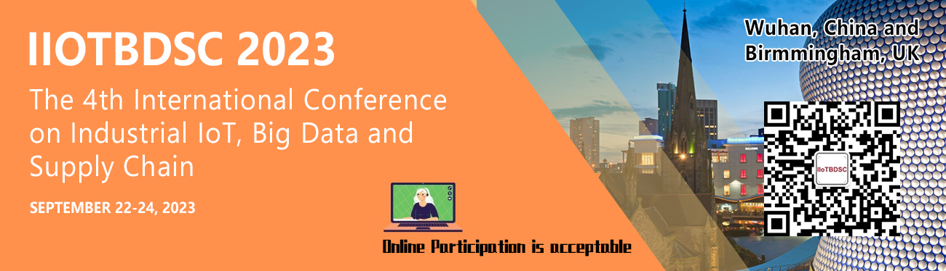

The 4th International Conference on Industrial IoT, Big Data and Supply Chain
Conference Date: September 22-24, 2023
Submission Due：August 31, 2023
Notification of Acceptance：September 15, 2023
Venue: Wuhan, China and Birmmingham, UK
*Online: participation is acceptable Conference website: http://www.iiotbdsc.com/2023/

Organizer :
Co-organizers :
Conference Chair
-Prof. Victor Chang
Aston University, United Kingdom

Organizing Chair
-Associate professor. BinChen
JLijiang culture and tourism college,China

Honorary Chair
-Prof. Xilong Qu
Hunan University of Finance and Economics, Changsha, Hunan, China

International Advisory Chair
-Prof. Dr. Anna Kobusinska
Poznań University of Technology, Poland
-Prof. Dr. Flávia C. Delicato
Fluminense Federal University, Brazil

Program Chairs
-Prof. Yongxin Zhu
University of Chinese Academy of Sciences, Shanghai, China
-Prof. Hong Yu
Chongqing University of Posts and Telecommunications, China

Workshop/Local Chairs
-Dr. Simon Fong
University of Macau, China
-Prof. Shadi A. Aljawarneh
Jordan University of Science and Technology, Jordan

Publicity Chairs
-Prof. Lianyong Qi
Qufu Normal University, China
-Prof. Gang Sun
University of Electronic Science and Technology of China, China
-Dr. Zakaria Benzadri
University of Constantine 2, Algeria
-Dr. Gaurav Dhiman
Government Bikram College of Commerce, Patiala, India
-Dr. Chao Liu
Aston University, United Kingdom
-Dr. Vitor Jesus
Aston University, United Kingdom

AB O U T I I O T B D SC 2023

We live in an interconnected world that different smart devices and people are connected together. The advancement of high-tech services and reliability, efficiency, speed and accuracy of services have become crucial and popular in many aspects. The key elements include the Industrial Internet of Things, Big Data and Supply Chain.

The Industrial Internet of Things (IIoT) is a platform that allows a network of devices (sensors, smart meters, etc.) to communicate, analyze data and process information collaboratively in the service of individuals or organizations. Big Data (BD) has core values of volume, velocity, variety and veracity. Supply Chain requires the modern advancement and support from IIoT and Big Data, to make all services efficient, fast, accurate and reliable. These three can combine and work together to produce greater impacts and contributions as follows. First, the issues surrounding IIoT devices, their interconnectedness and services they may offer, including efficient, effective and secure analysis of the data IIoT produces. Often machine learning and other advanced techniques, models and tools, and issues of security and trust are related. The maturity of IoT technologies can grow and become part of our everyday lives. Second, BD can be jointly used with machine learning, AI, statistical and other advanced techniques, models and methods, which can create values for people and organizations adopting it. Forecasting, deep analysis and analytics can help identify weaknesses and make improvements based on different analysis. Third, suppliers can know the updates on their stocks and demands. Manufacturers and transport companies know the workloads, destination and resource distributions. Finally, customers can know the real-time updates of the delivery of their goods. Investors can better decisions on their goods, resources, sales and management. Supply chain can reach a greater sustainable ecosystem with the help of IIoT and Big Data.

This conference brings the experts, practitioners, scientists and decision-makers from academia and industry together. Our aim is to foster a strong, lively and well-connected international research community. We welcome innovative ideas, concepts, services, techniques, research outputs and business practices.

Call for Papers
Area 1: Industrial Internet Of Things (Iiot) Fundamentals And Applications
Area 2: Big Data Research And Multi- Discipline Services
Area 3: Supply Chain Fundamentals
Area 4: Advanced Supply Chain And Iiot- Bd Integration
Area 5: Emerging Areas

Publication and Index
Proceeding
All papers, both invited and contributed, will be reviewed by at least 3 experts from the committees. After a careful reviewing process before the final decision and detailed presentation at the conference, all the accepted paperswillbepublishedin EI, Scopus, CPCI indexed proceeding from a top publisher.

Journals
Some of the best papers of IIoTBDSC2023
will have the chances to be recommended to SCI / EI journals for publishing, In suchcase, the papers must be significantly changed after improvement and expanding - usually, at least 30% changes are requested.

- Cyber Security and Applications
- Expert Systems Wiley (WOS SCI Q2, ABS/AJG 2)
- Journal of Grid Computing (WOS SCI Q1)
- Journal of Global Information Management (JGIM, WOS Q2, ABS 2, ABDC A)
- SN Computer Science (Scopus)
- Decision Analytics Journal (Scopus)
- Symmetry (WOS SCI Q2)
- Computers, Materials & Continua (EI, etc)
- International Journal of Organizational and Collective Intelligence (IJOCI) (to be on Scopus)
- International Journal of Business and Systems Research (Scopus, ABS/AJG1)
- Axioms (WOS SCI Q2)

CONFERENCE HISTORY

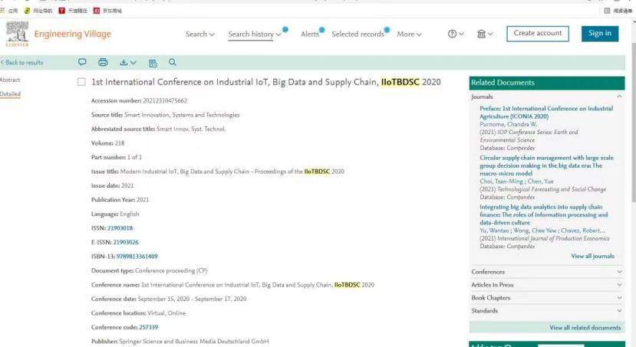

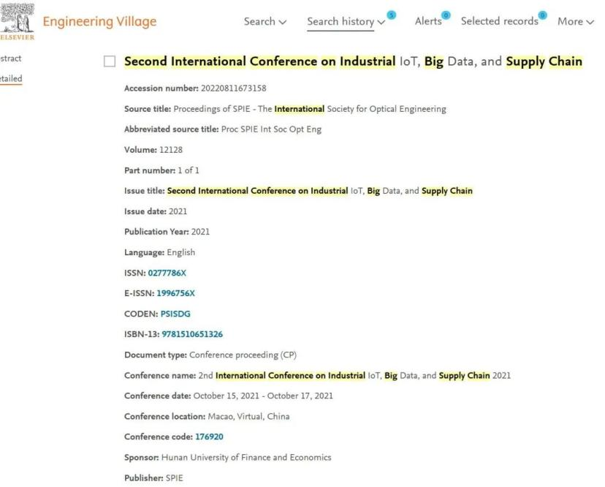

More information on publication of IIoTBDSC2020, please hit the link: https://link.springer.com/book/10.1007/978-981-33-6141-6

More information on publication of IIoTBDSC2021, please hit the link: https://www.spiedigitallibrary.org/conference-proceedings-of-SPIE/12128.toc

For more information on IIoTBDSC2022 please click the link: http://www.iiotbdsc.com/2022/

Review
All submissions to this conference will be sent to at least 2 independent reviewers selected from a group of well-established researchers by the Editor-in-Chief and evaluated based on originality, technical and research content, relevance to conference, contributions, and readability. The full paper submissions will be chosen based on technical merit, interest, applicability, and how well they fit a coherent and balanced technical program.

Submission
Requests for Submissions
1) English is the official language of the conference, and all of the papers should be written and presented only in English.
2) All of the papers should be submitted in WORD and PDF formats, and all of the papers should be typeset according to the template on the official website.
3) All of the papers submitted to the conference should report original, previously unpublished research results, experimental or theoretical, which should not be under consideration for publication elsewhere, and the copyrights of the papers should not have been demised to any institution, organization or individual.

Submission Method
Prospective authors are invited to submit their full papers (including all sections, figures, tables and references) via email at iiotbdscconference@126.com.

Contact us
Conference Secretary: Sunny Zhang
Submission Email:
iiotbdsccoference@126.com
QQ：3374931065
M/P: +86-13297998135

